
Total: 118
Weighting 4%
Year 11 ATAR Geography
Task 4A - Fieldwork Booklet
Unit 2 – Global Networks and Interconnections
Depth Study One – Tourism
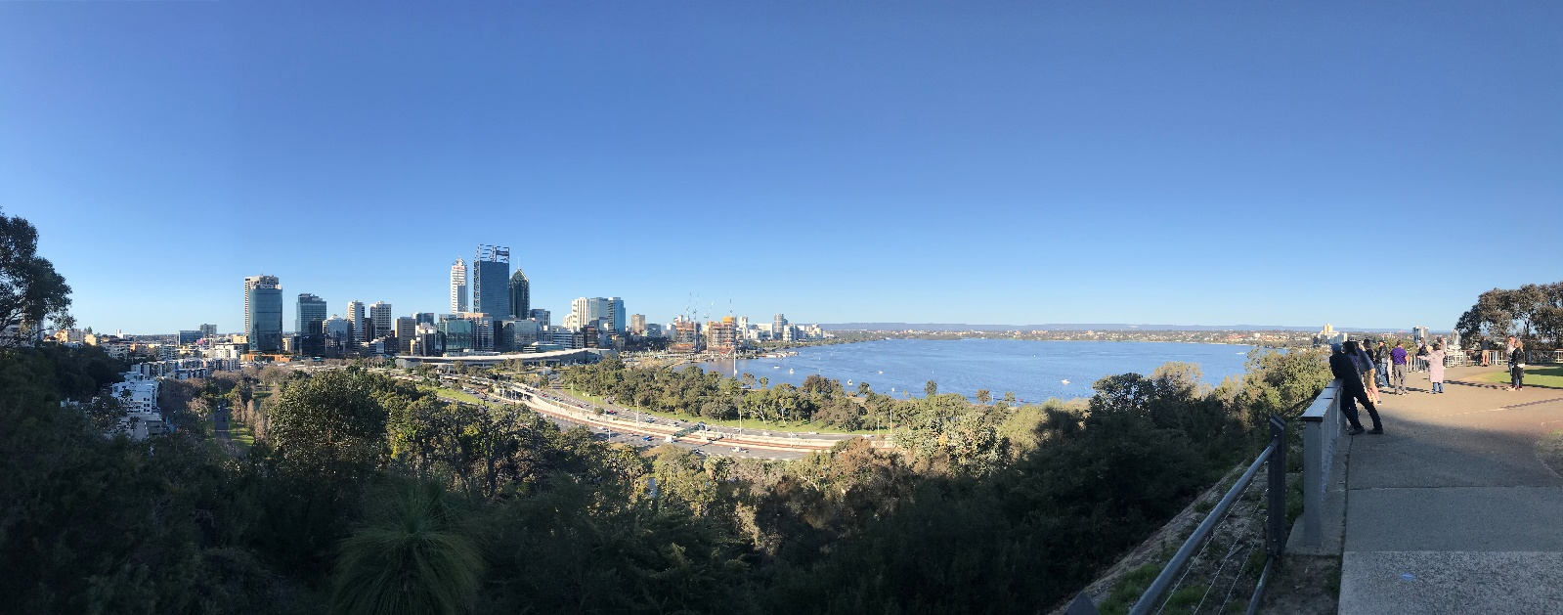
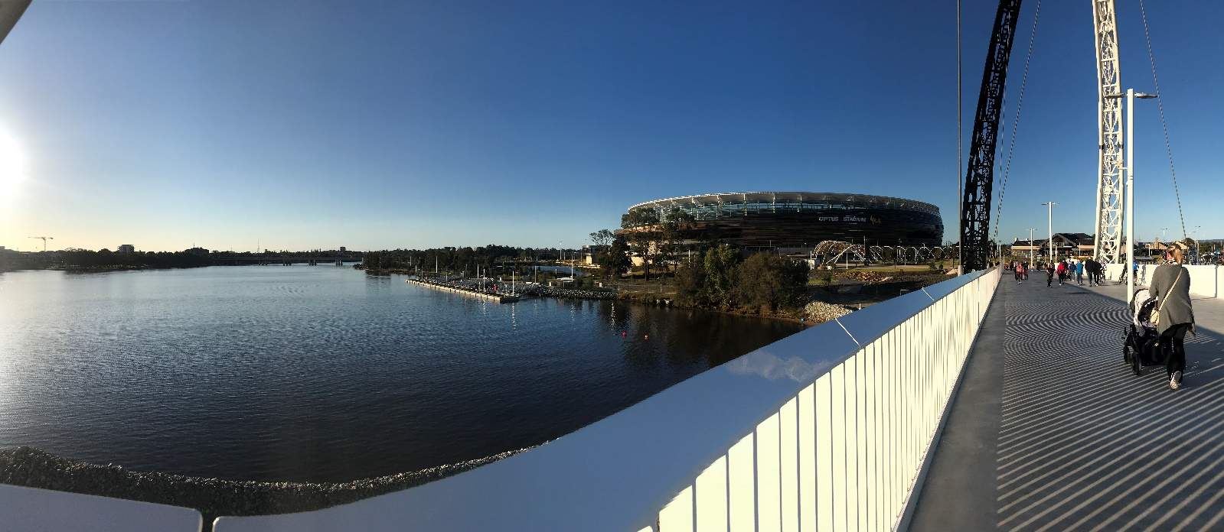

Name: _________________________________________
Date: __________________________________________
Site One: Optus Stadium
- Outline 2 Site and 2 Situation features or characteristics of Optus Stadium: (4 marks)
Site
- ____________________________________________________________________________________________________________________________________________________________________________________________________________________________________________________________________________________________________________________________________________________

- ____________________________________________________________________________________________________________________________________________________________________________________________________________________________________________________________________________________________________________________________________________________
Situation
- ____________________________________________________________________________________________________________________________________________________________________________________________________________________________________________________________________________________________________________________________________________________

- ____________________________________________________________________________________________________________________________________________________________________________________________________________________________________________________________________________________________________________________________________________________2. Make a 5 list of features of Optus Stadium that make it a tourism asset: (5 marks)
- _________________________________________________________________________________
- _________________________________________________________________________________
- _________________________________________________________________________________
- _________________________________________________________________________________
- _________________________________________________________________________________
- Describe the role of Government at Optus Stadium. (2 marks)
___________________________________________________________________________________________________________________________________________________________________________________________________________________________________________________________________________________________________________________________________________________________________________________________________________________________________________________
- State an example of an enterprise at Optus Stadium and briefly describe the role of they have at Optus Stadium. (Hint: How do they contribute to tourism?) (2 marks)
____________________________________________________________________________________________________________________________________________________________________________________________________________________________________________________________________________________________________________________________________________________________________________________________________________________________________
- List 4 transport options used to access Optus Stadium. (4 marks)

- _________________________________________________________________________________
- _________________________________________________________________________________
- _________________________________________________________________________________
- _________________________________________________________________________________

- Make notes and observations during your tour of Optus Stadium; particularly in relation to tourism in Perth and the role of Optus Stadium. (20 marks)
Name of Tour Guide: ____________________________________________________________________________
- ________________________________________________________________________________________________________________________________________________________________________________________________________________________________________________________________________________________________________________________________________________________________
________________________________________________________________________________________________________________________________________________________________________________

- ________________________________________________________________________________________________________________________________________________________________________________________________________________________________________________________________________________________________________________________________________________________________
________________________________________________________________________________________________________________________________________________________________________________

- ________________________________________________________________________________________________________________________________________________________________________________________________________________________________________________________________________________________________________________________________________________________________
________________________________________________________________________________________________________________________________________________________________________________

- ________________________________________________________________________________________________________________________________________________________________________________________________________________________________________________________________________________________________________________________________________________________________
________________________________________________________________________________________________________________________________________________________________________________

- ________________________________________________________________________________________________________________________________________________________________________________________________________________________________________________________________________________________________________________________________________________________________
________________________________________________________________________________________________________________________________________________________________________________

- ________________________________________________________________________________________________________________________________________________________________________________________________________________________________________________________________________________________________________________________________________________________________
________________________________________________________________________________________________________________________________________________________________________________

- ________________________________________________________________________________________________________________________________________________________________________________________________________________________________________________________________________________________________________________________________________________________________
________________________________________________________________________________________________________________________________________________________________________________

- ________________________________________________________________________________________________________________________________________________________________________________________________________________________________________________________________________________________________________________________________________________________________
________________________________________________________________________________________________________________________________________________________________________________

- ________________________________________________________________________________________________________________________________________________________________________________________________________________________________________________________________________________________________________________________________________________________________
________________________________________________________________________________________________________________________________________________________________________________

- ________________________________________________________________________________________________________________________________________________________________________________________________________________________________________________________________________________________________________________________________________________________________
________________________________________________________________________________________________________________________________________________________________________________

- Field sketch: Arriving at Gate C looking out over towards the CBD in a westerly direction, complete a quick sketch of the area in front of you. Remember to use pencil and include a title. (8 marks)

Label the following:
- Swan River
- Central Business District
- Optus Stadium
- BHP Boardwalk
- Matagarup Bridge
- Hotels in South Perth

Hints:
- Only show main features
- Make sure your sketch is clear and easy to read/understand
- Ensure you annotate your sketch by adding brief notes (2 – 3 words for each note)
- You may like to use a key to add extra notes
- It highlights main features, including elements above
Fieldwork Sketch
Title: _______________________________________________________________________________ Date: _____________________________________

Site Two: Kings Park and Botanic Garden
- Outline 2 Site and 2 Situation features or characteristics of Kings Park and Botanic Garden: (6 marks)
Site
- ____________________________________________________________________________________________________________________________________________________________________________________________________________________________________________________________________________________________________________________________________________________

- ____________________________________________________________________________________________________________________________________________________________________________________________________________________________________________________________________________________________________________________________________________________
Situation
- ____________________________________________________________________________________________________________________________________________________________________________________________________________________________________________________________________________________________________________________________________________________

- ____________________________________________________________________________________________________________________________________________________________________________________________________________________________________________________________________________________________________________________________________________________
- Make a 5 list of features of Kings Park and Botanic Garden that make it a tourism asset: (5 marks)

- _________________________________________________________________________________
- _________________________________________________________________________________
- _________________________________________________________________________________
- _________________________________________________________________________________
- _________________________________________________________________________________
- Describe the role of Government at Kings Park and Botanic Garden. (2 marks)
___________________________________________________________________________________________________________________________________________________________________________________________________________________________________________________________________________________________________________________________________________________________________________________________________________________________________________________
- State an example of an enterprise at Kings Park and briefly describe the role of they have at Kings Park and Botanic Garden. (Hint: How do they contribute to tourism?) (2 marks)
____________________________________________________________________________________________________________________________________________________________________________________________________________________________________________________________________________________________________________________________________________________________________________________________________________________________________
- List 4 transport options used to access Kings Park and Botanic Garden. (4 marks)

- _________________________________________________________________________________
- _________________________________________________________________________________
- _________________________________________________________________________________
- _________________________________________________________________________________
- Make notes and observations during your tour of Kings Park and Botanic Garden; particularly in relation to tourism in Perth and the role of Kings Park and Botanic Garden. (20 marks)

Name of Tour Guide: _____________________________________________________________________________
- ________________________________________________________________________________________________________________________________________________________________________________________________________________________________________________________________________________________________________________________________________________________________
________________________________________________________________________________________________________________________________________________________________________________

- ________________________________________________________________________________________________________________________________________________________________________________________________________________________________________________________________________________________________________________________________________________________________
________________________________________________________________________________________________________________________________________________________________________________

- ________________________________________________________________________________________________________________________________________________________________________________________________________________________________________________________________________________________________________________________________________________________________
________________________________________________________________________________________________________________________________________________________________________________

- ________________________________________________________________________________________________________________________________________________________________________________________________________________________________________________________________________________________________________________________________________________________________
________________________________________________________________________________________________________________________________________________________________________________

- ________________________________________________________________________________________________________________________________________________________________________________________________________________________________________________________________________________________________________________________________________________________________
________________________________________________________________________________________________________________________________________________________________________________

- ________________________________________________________________________________________________________________________________________________________________________________________________________________________________________________________________________________________________________________________________________________________________
________________________________________________________________________________________________________________________________________________________________________________

- ________________________________________________________________________________________________________________________________________________________________________________________________________________________________________________________________________________________________________________________________________________________________
________________________________________________________________________________________________________________________________________________________________________________

- ________________________________________________________________________________________________________________________________________________________________________________________________________________________________________________________________________________________________________________________________________________________________
________________________________________________________________________________________________________________________________________________________________________________

- ________________________________________________________________________________________________________________________________________________________________________________________________________________________________________________________________________________________________________________________________________________________________
________________________________________________________________________________________________________________________________________________________________________________

- ________________________________________________________________________________________________________________________________________________________________________________________________________________________________________________________________________________________________________________________________________________________________
________________________________________________________________________________________________________________________________________________________________________________

- Field sketch: looking out over the CBD and the Swan River, in an easterly direction, complete a quick sketch of the area in front of you. Remember to use pencil and include a title. (8 marks)

Label the following:
- Swan River
- Central Business District
- Elizabeth Quay
- Darling Scarp
- South Perth Ferry Terminal
- Major Transport Links – Kwinana Freeway
- Perth Convention Centre
- South Perth Hotels

Hints:
- Only show main features
- Make sure your sketch is clear and easy to read/understand
- Ensure you annotate your sketch by adding brief notes (2 – 3 words for each note)
- You may like to use a key to add extra notes
- It highlights main features, including elements above
Fieldwork Sketch
Title: _______________________________________________________________________________ Date: ___________________________________

- Survey (20 marks)
In pairs devise 4 survey questions asking 4 people at Kings Park and Botanic Gardens about their experience. Ensure you are respectful and remember that you are ambassadors for our school. You make like to introduce yourselves with something like… “Excuse me, we are NAME and NAME and we are Geography students from Narrogin Senior High School investigating Tourism at Kings Park. We wondered if you wouldn’t mind answering some simple survey questions from us.” Your questions should focus on gathering information about why people visit the park, where they are from (International, Interstate, Intrastate visitor etc.) and tourism. You are working to gather data to prove or disprove the hypothesis “The majority of visitors to Kings Park and Botanic Garden are international visitors.”
Survey Questions:

- ___________________________________________________________________________________________________________________________________________________________________________________________________________________________________________________

- ___________________________________________________________________________________________________________________________________________________________________________________________________________________________________________________

- ___________________________________________________________________________________________________________________________________________________________________________________________________________________________________________________

- ___________________________________________________________________________________________________________________________________________________________________________________________________________________________________________________

- ___________________________________________________________________________________________________________________________________________________________________________________________________________________________________________________

Survey Responses
Person | 1. | 2. | 3. | 4.
Question

16: What if… there is a cable car built that connected Kings Park to Elizabeth Quay. Describe the potential impacts this would have on the following: (6 marks)

- Economy
________________________________________________________________________________________________________________________________________________________________________________________________________________________________________________________________________________________________________________________________________________________________________________________________________________________________________________________________________________________________________________________________________________________________________________________________________________________________________________________________________________________________

- Visitors to Kings Park
________________________________________________________________________________________________________________________________________________________________________________________________________________________________________________________________________________________________________________________________________________________________________________________________________________________________________________________________________________________________________________________________________________________________________________________________________________________________________________________________________________________________

- The Environment
________________________________________________________________________________________________________________________________________________________________________________________________________________________________________________________________________________________________________________________________________________________________________________________________________________________________________________________________________________________________________________________________________________________________________________________________________________________________________________________________________________________________

Extra Page:

